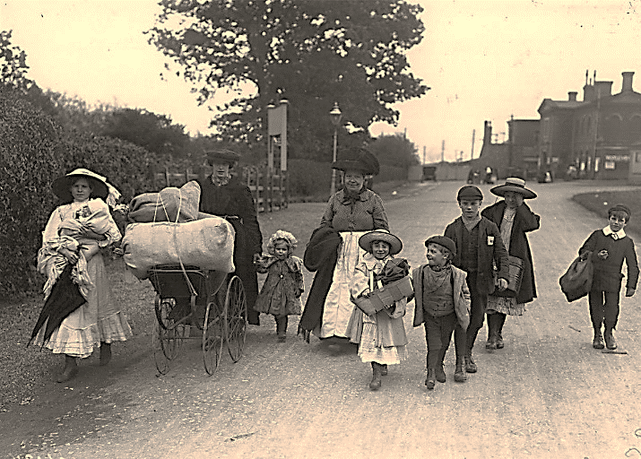
Parking at Hoppers
Hoppers wasn’t built for cars or minibuses...
All Mini buses and large vehicles can find suitable parking in the recreation ground car park Falmouth Place, Five Oak Green, TN12 6RD; see the map below.
Smaller cars can be parked in the front court yard, however take care many a car has been damaged turning left into Hoppers. We therefore advise you to only enter under Hoppers entrance from the right.
Once in the front courtyard please be careful to avoid hitting the supporting pillars.
